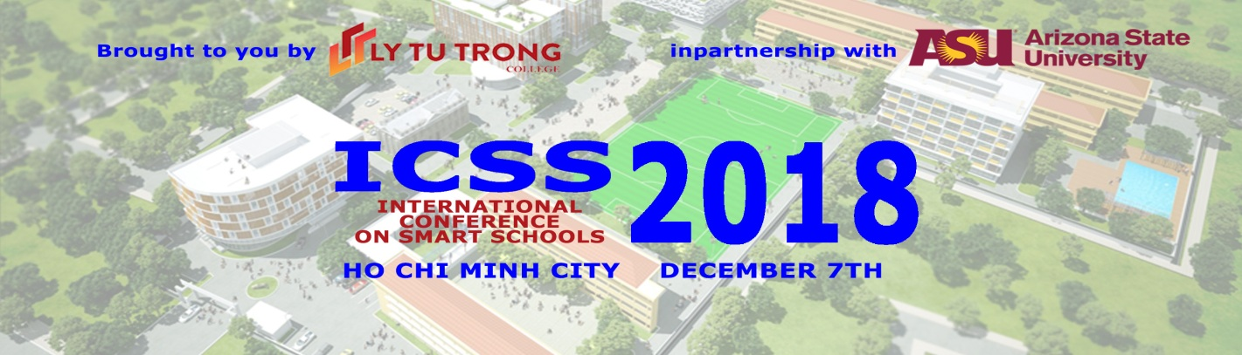
November 2nd, 2018

Dear colleagues,

On behalf of Ly Tu Trong College of Ho Chi Minh city, Arizona State University and our partners, it is our pleasure to invite you to participate in our 7th International Conference on Smart Schools 2018 :
“”

ICSS2018 was created to serve both public and private institutions that are poised to enhance their academic programs in the quickly evolving fields of Smart Education. It has been designed to inspire educators to find new ways to encourage students to think outside of the box, along with better ways of engaging industry as we embark on a new era of Industry 4.0.

Academia, industry, and government leaders at ICSS2018 will participate in a days of interactive plenary and technical sessions, panel discussions, exhibits and seminars that will pave paths for new ventures and partnerships via Ly Tu Trong College and Arizona State University extended network.

Online Conference registration is limited and highly recommended for all of our honored guests and invitees. Please confirm your participation and that of your guests in the conference by registering online at stemcon.heeap.org before the deadline of November 18th, 2018. Online registration includes lunch and open access to all plenary and afternoon sessions at the venue. General conference information is included below:
Location: Ly Tu Trong College
Date: December 7, 2018
Time: 7:30 - 17:00 hrs

More details about ICSS 2018 can be found on the webpage mentioned above. Please contact Ms. Trang Nguyen, at 098456241 or nguyenngoctrang@lttc.edu.vn with any additional questions.
We look forward to welcoming you at ICSS 2018 as we work collectively to advance smart education in Vietnam.

Best regards,
Pham Huu Loc  Rector of Ho Chi Minh City | Jeffrey S. Goss  Associate Vice Provost, Vietnam/SE Asia Programs  Assistant Dean/ Executive Director  Ira A Fulton Schools of Engineering  Office of Global Outreach and Extended Ed. Arizona State University

